Skin Cancer Detection App

DermScan App
Simple Workflow Documentation
Dataset Training, Backend, and Frontend

1. Overall Workflow
This project has three main parts. First, the model is trained using the HAM10000 skin lesion dataset. Second, the trained model is connected to a Flask backend API. Third, a Flutter mobile application sends an image to the backend and displays the prediction result to the user.
Part | Main Job | Output
Dataset Training | Prepare data and train the deep learning model | best_model.h5
Backend (Flask) | Load the model and create a prediction API | JSON response
Frontend (Flutter) | Send image and show the prediction to the user | Mobile app result screen

2. Dataset Training
The training part is used to teach the AI model how to identify different types of skin lesions. The project uses the HAM10000 dataset from Kaggle. This dataset contains many dermoscopic skin images with class labels.

Step 1: Download the dataset
Download the HAM10000 dataset from Kaggle. After downloading, the image files and metadata CSV file are stored in the project workspace.

Step 2: Clean the dataset
Check the metadata for missing values such as age or sex. Fill missing values, fix formatting issues, and make sure the labels are correct. This step improves data quality before training.
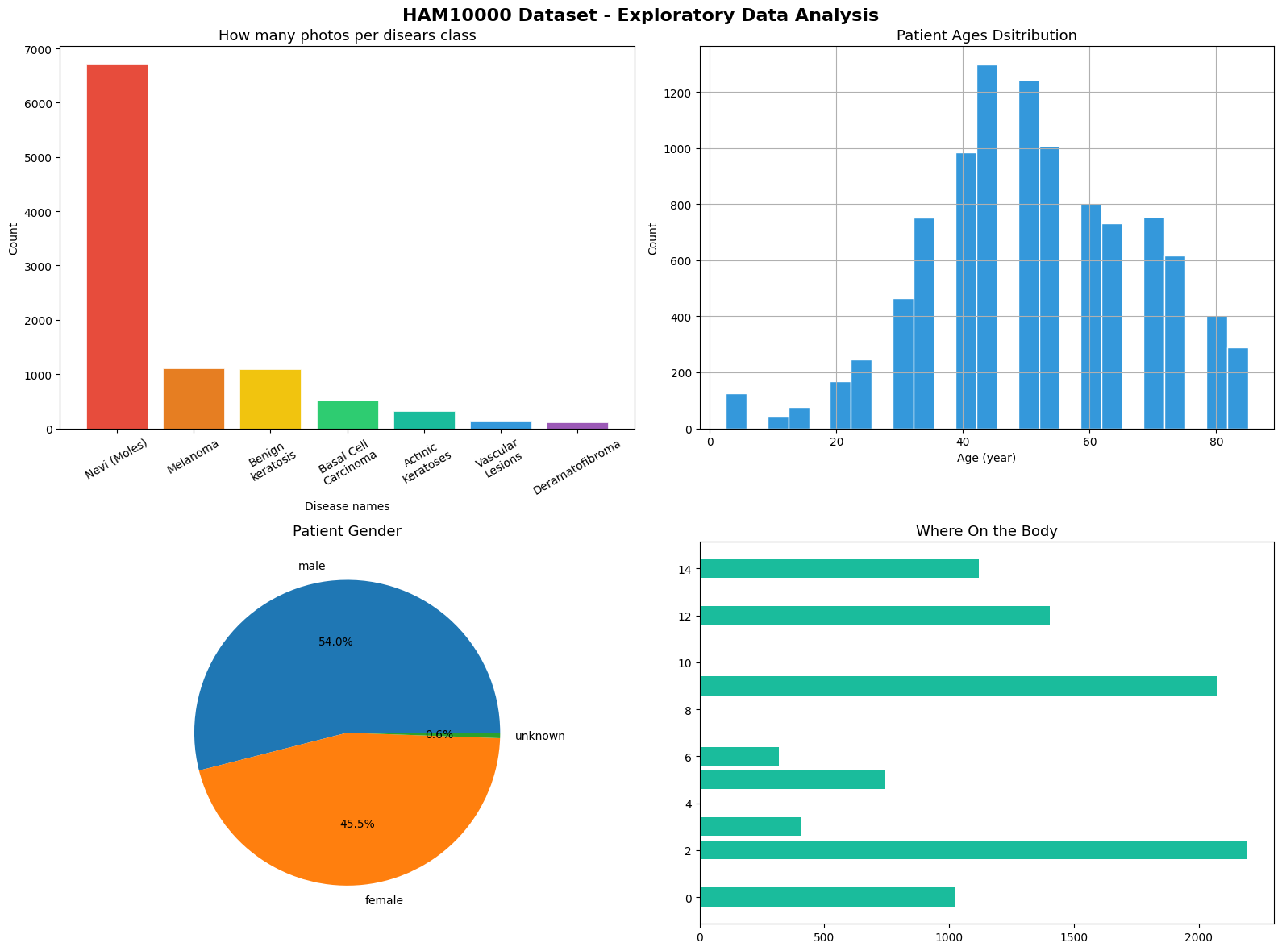

Step 3: Preprocess the images
Resize images to a fixed size such as 224 x 224 so that all images match the model input size. Normalize pixel values so the model can learn more effectively.
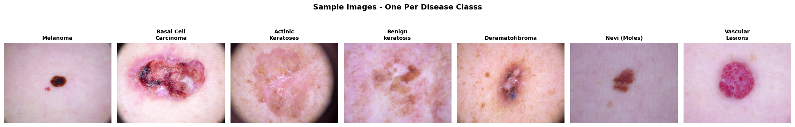

Step 4: Train the model
Use TensorFlow and Keras to train a CNN-based model. In this project, MobileNetV2 or EfficientNet can be used as the base architecture. During training, the model learns patterns such as color, shape, and border differences in the lesion images.

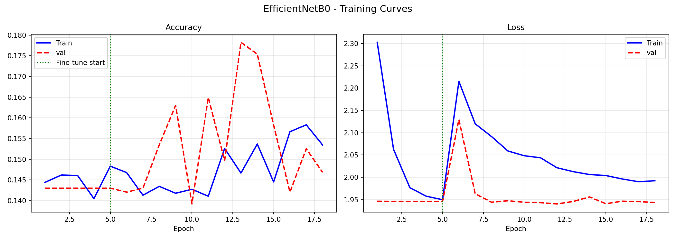

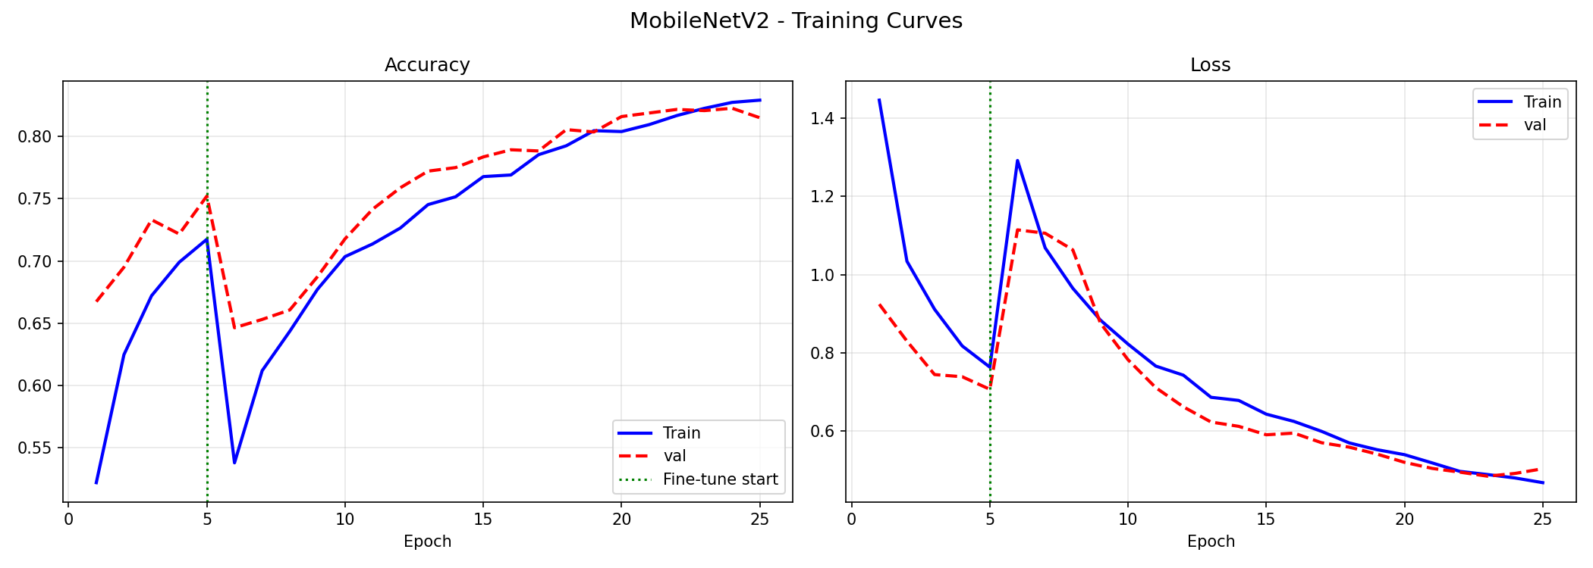

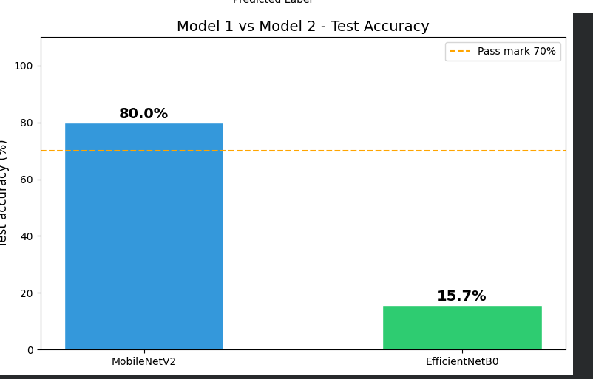

Step 5: Save the trained model
After training finishes, save the best model file as best_model.h5. This file is later used by the backend to make predictions.

Why this part is important
If the dataset is not cleaned properly or the images are not prepared correctly, the model accuracy can become low. A good training process helps the app give more reliable prediction results.
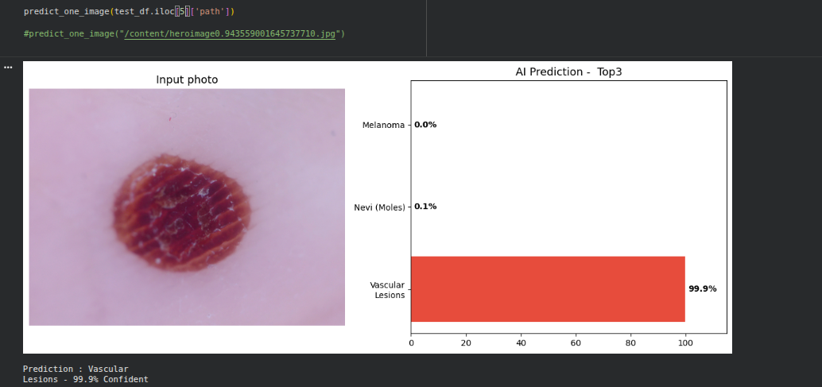

3. Backend (Flask API)
The backend acts like the middle part between the mobile app and the trained model. It receives an image from the Flutter app, processes it, runs the model, and sends back the result.

Step 1: Create the Flask server
Create a Flask application in Python. This server listens for requests from the frontend.

Step 2: Load the trained model
When the server starts, load best_model.h5 into memory. This allows the backend to use the trained model without retraining it every time.

Step 3: Create the prediction endpoint
Create an API route such as /predict. This endpoint is used by the Flutter app to send an image file for prediction.

Step 4: Receive and preprocess the image
When the user sends an image, the backend reads the file, resizes it to 224 x 224, converts it into an array, and normalizes it in the same way used during training.

Step 5: Run prediction and return JSON
The backend sends the processed image to the model. The model predicts the disease class and confidence score. Then Flask returns the result as a JSON response.

Example backend response
Example: {"prediction": "Melanoma", "confidence": 68.7}

4. Frontend (Flutter App)
The frontend is the user interface of the project. It allows the user to select or capture a skin image and view the AI prediction result in a simple mobile screen.
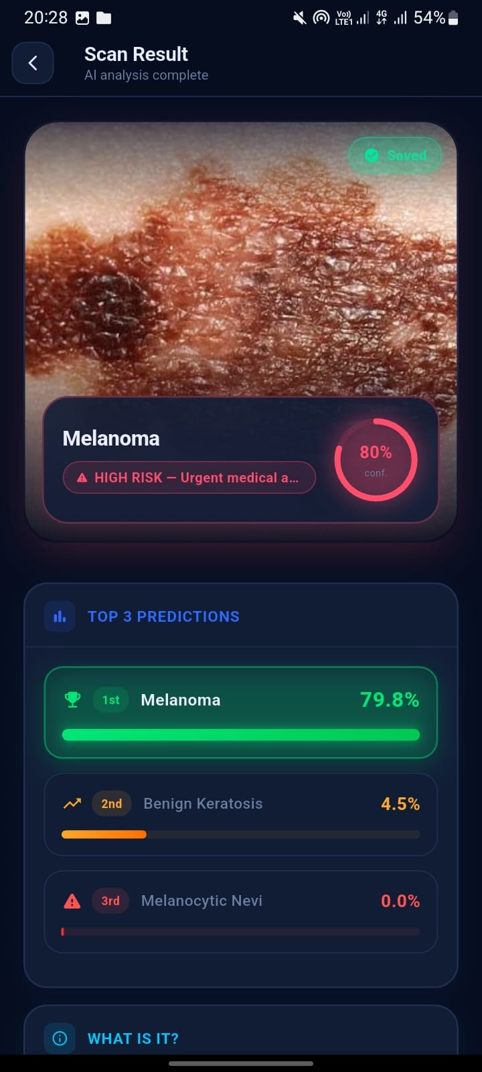
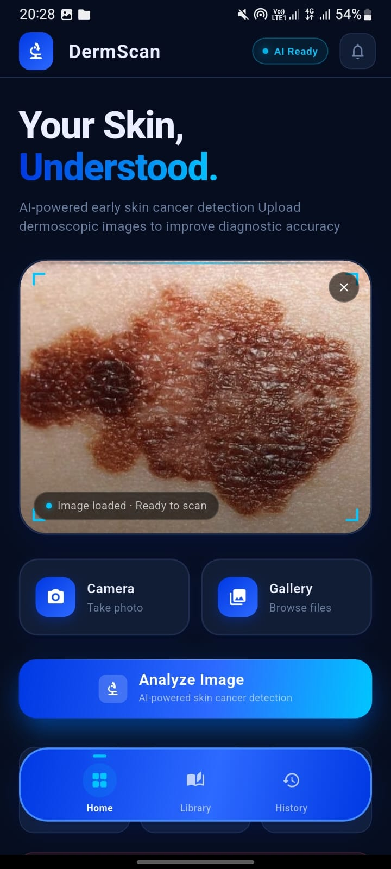
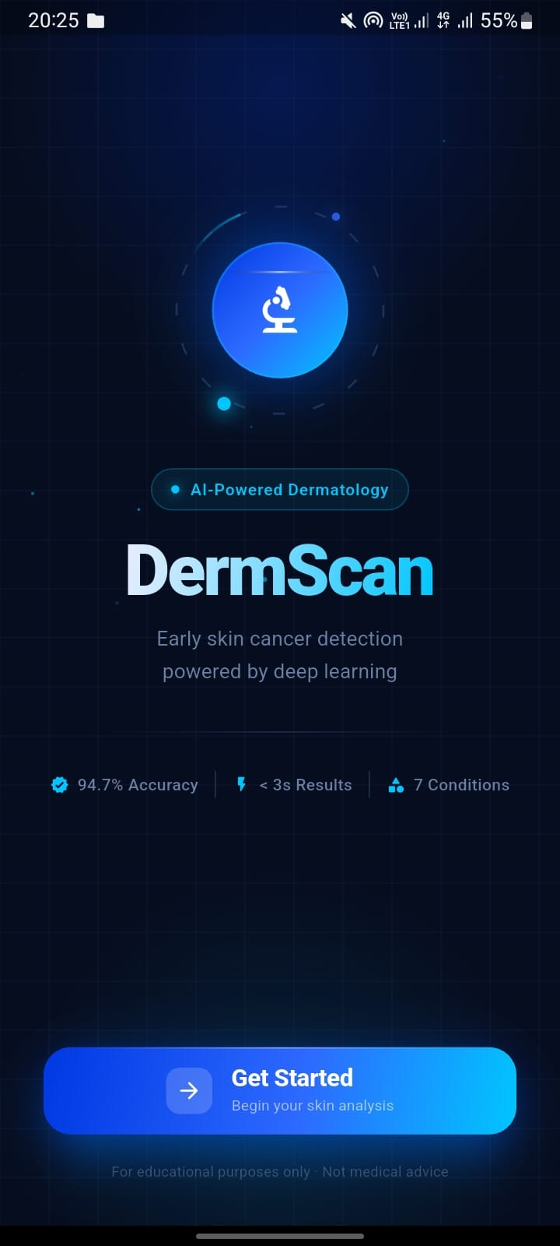

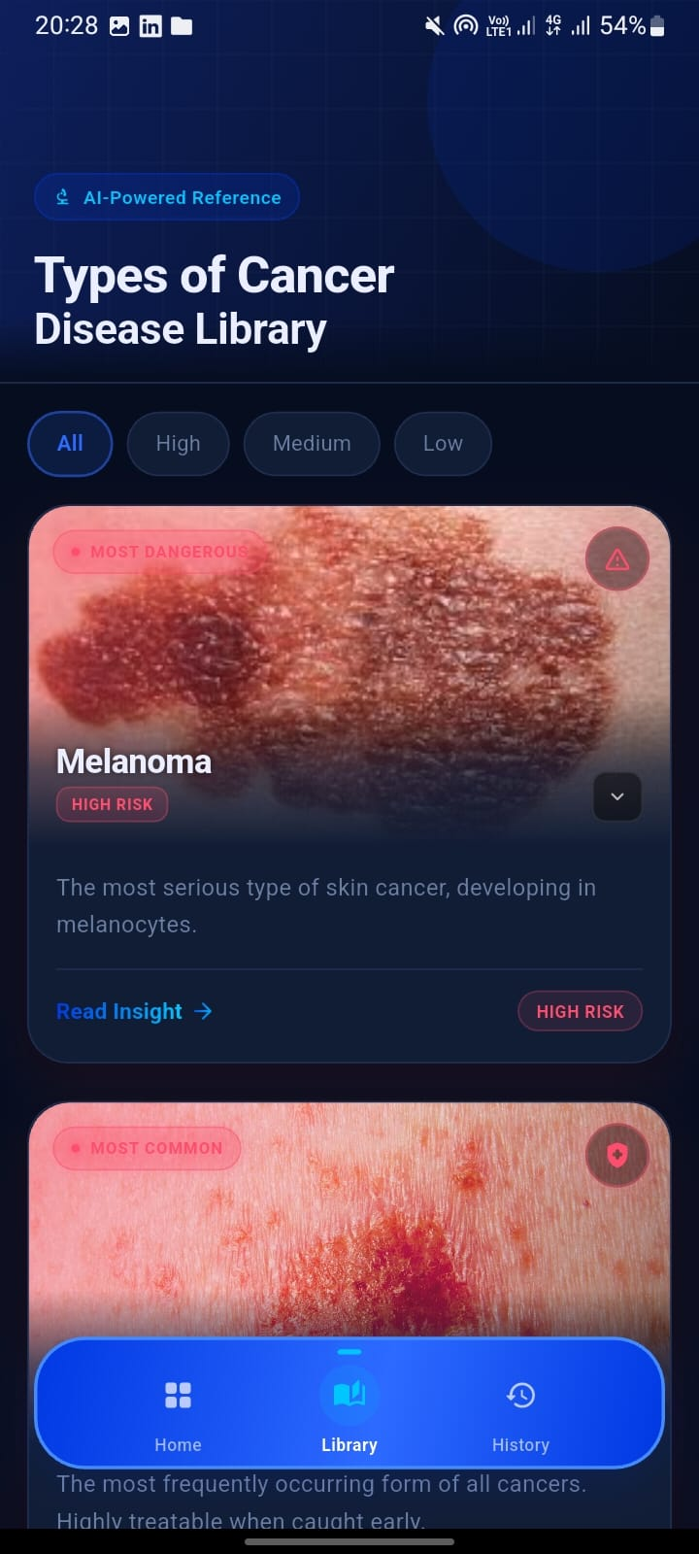
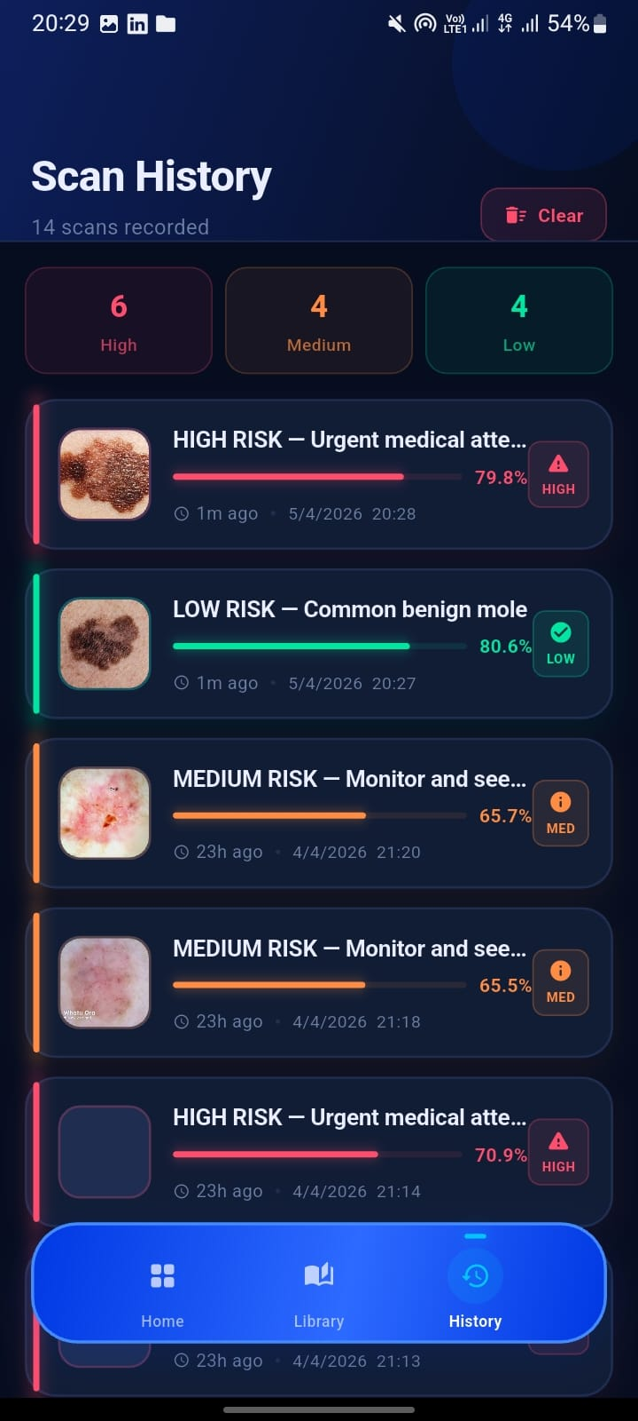

Step 1: Create the mobile UI
Design a clean screen with buttons for choosing an image from the gallery or capturing a photo from the camera.

Step 2: Select an image
The user chooses a skin image. The selected image is shown on the screen before prediction.

Step 3: Send image to the backend
Use an HTTP POST request to send the image file from Flutter to the Flask /predict API endpoint.

Step 4: Receive the prediction result
The Flutter app receives the JSON response from the backend. This response contains the predicted disease name and the confidence value.

Step 5: Display the final result
Show the disease name, confidence score, and any additional information on the result screen so the user can understand the prediction.

5. End-to-End Flow
The complete workflow can be explained like this:
- Train the deep learning model using the HAM10000 dataset.
- Save the trained model as best_model.h5.
- Load the model inside the Flask backend.
- Build a /predict API to accept image files.
- Create the Flutter app user interface.
- User selects or captures a skin image.
- Flutter sends the image to the Flask backend.
- The backend preprocesses the image and runs the model.
- The backend returns the result as JSON.
- Flutter shows the prediction and confidence to the user.

6. Simple Conclusion
In simple words, the project starts by training an AI model with skin lesion images. That trained model is connected to a Flask backend. Finally, the Flutter frontend allows the user to send an image and view the prediction result. So the three main parts work together as one full system: training, backend, and frontend.

